**How to set up Alita**

1.When you download Alita, download it where you want to run the app

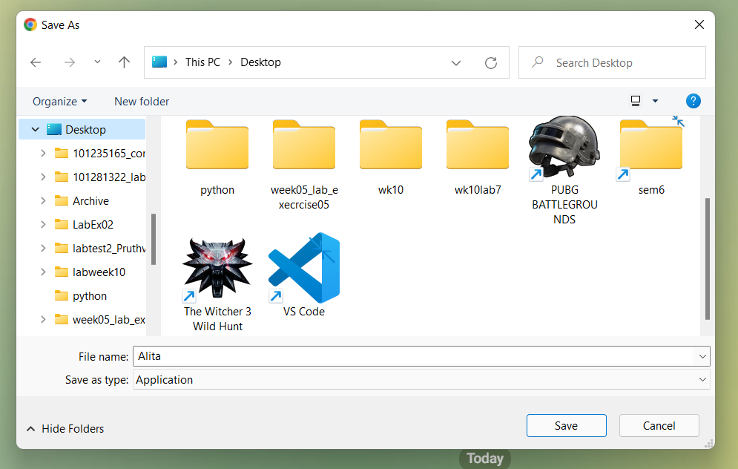

2.Alita has been downloaded



3.Once it downloaded, click on the icon and start process of install.

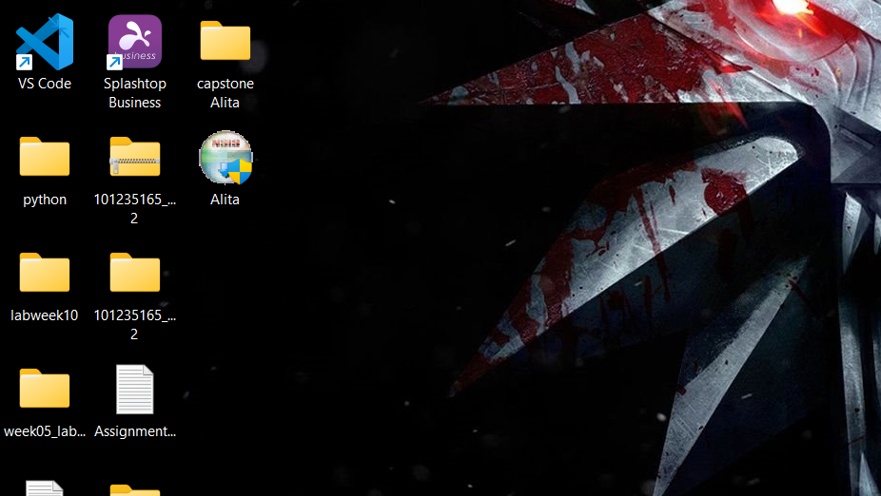

4.It will show you this prompt box and user should select “RUN ANTWAY” (Will not cause any problem to your emulator)

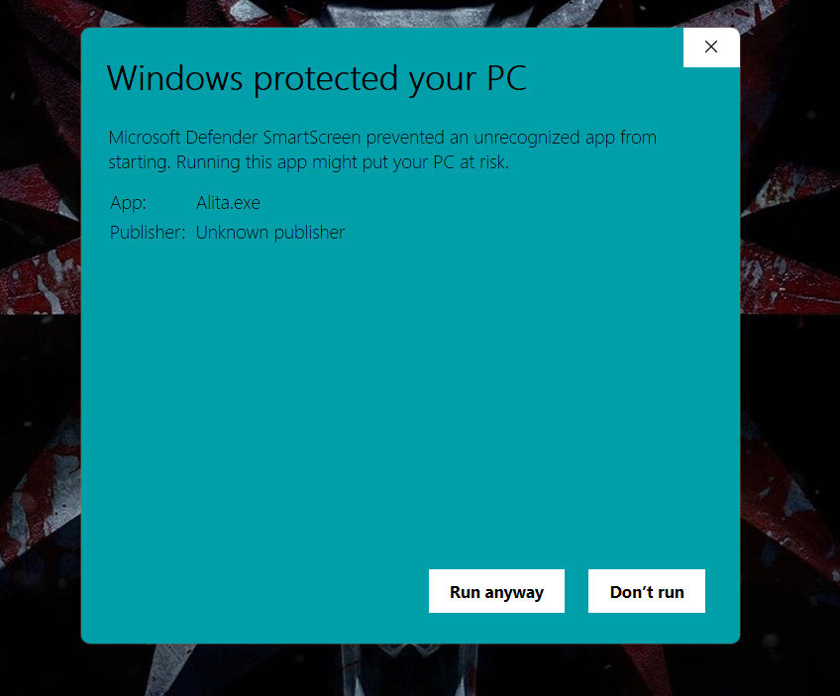

5.It will pop up following window, Press “YES”.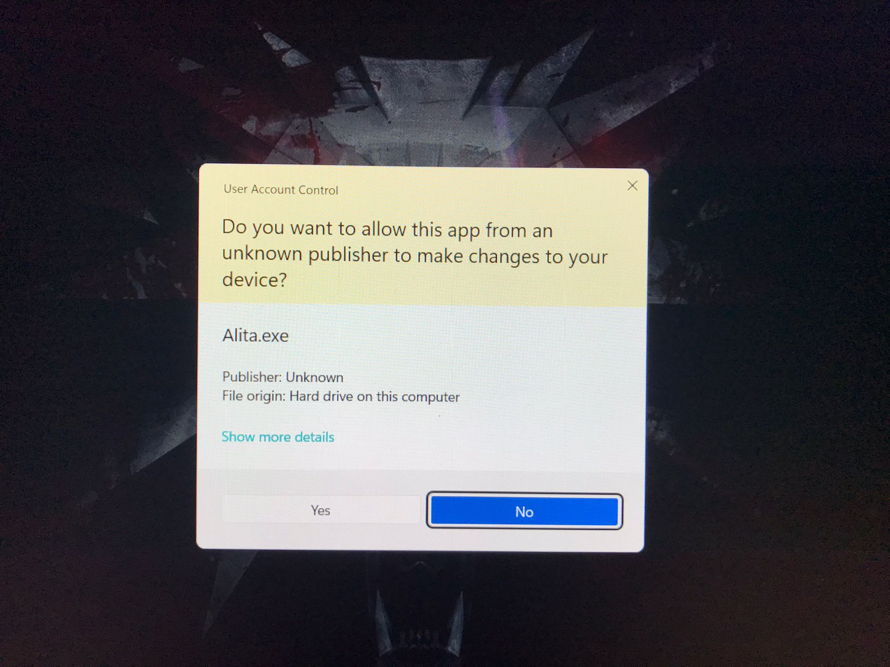

6.Please select where you want to install and press “INSTALL” button.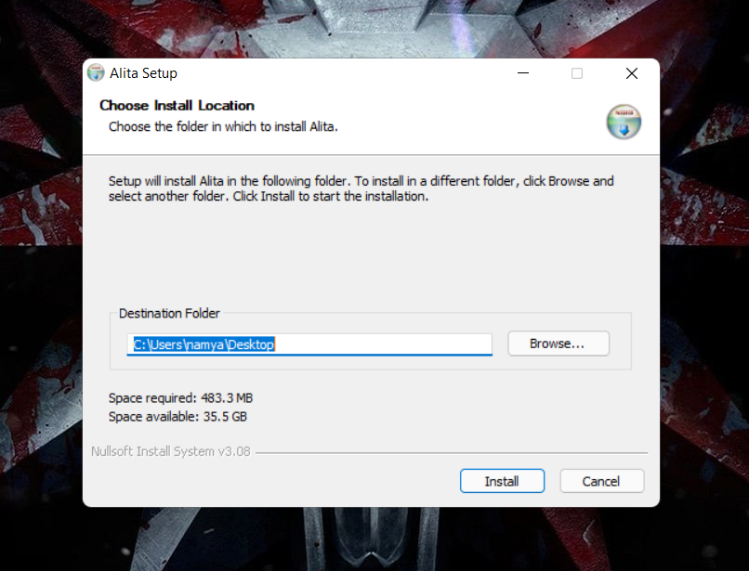

7.It will start installing Alita.

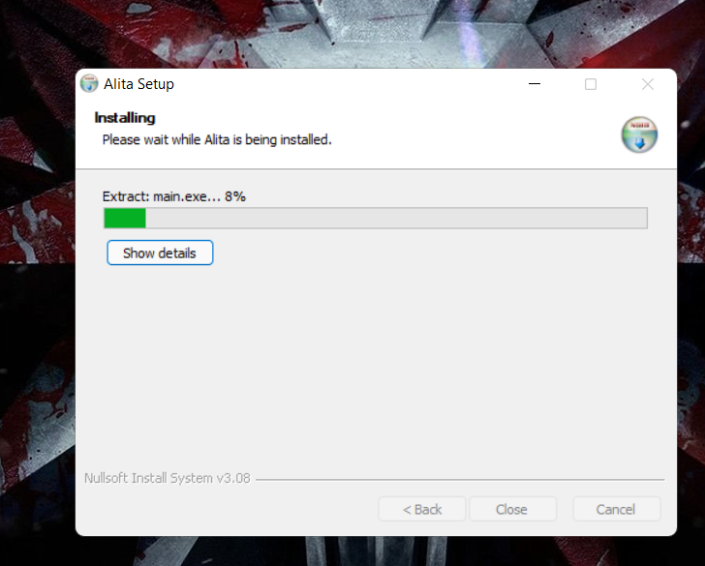

8.Once it finishes installing “Close” the window. And Open Application.

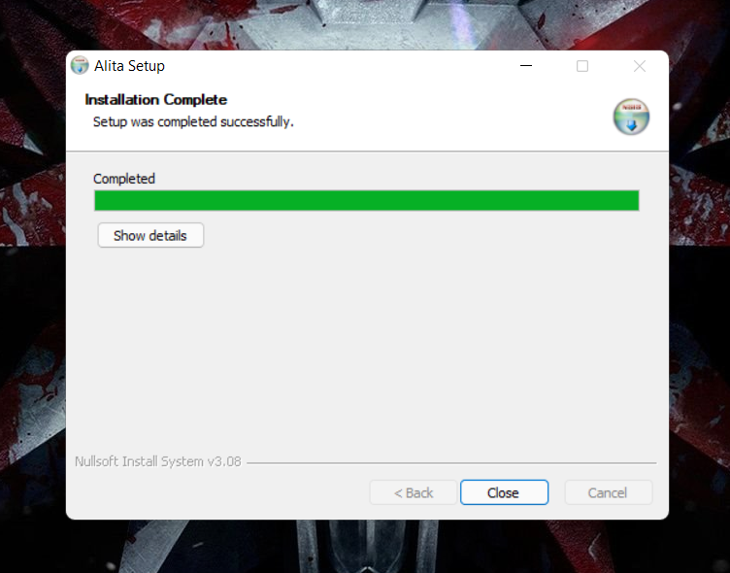

9. Please enter your name and email hit “PROCEED “and there you go you can start to use Alita